


Year 10
Semester 2
Investigation 1
Statistical Investigation

Your task is to create an informative poster presentation based on the collection and interpretation of data towards addressing a practical research question for the topic: COMMUNITY.

The poster will be completed in a small group of 2-3 people and all posters will be entered into a national competition. You are to create a poster (up to 84cm by 59cm) on a topic of your own choice. The poster may be presented in either a hard copy or a digital copy. It should be readable from 2 metres away. Your posters will be presented to the class before being sent away for judging in the SSAI competition.

Task Procedure
- Choose a topic question or problem that you will prove or answer using data.

- Complete a plan of action. Use the planning document attached to guide your project to completion.

- State your aim, hypothesis and give some background information.

- Collect the data you require. You MUST use ONLY secondary data sourced form a reliable source.

- Produce the data in a table of results.

- Display your data in appropriate graphical forms. (ie. histogram, comparative box plots, scatterplots. dot plot etc.)

- Analyse the data using appropriate techniques.

- Discuss the findings of your data analysis clearly outlining any possible biases or outliers and how you have dealt with these issues.

- Complete your conclusion.

- References

Please refer to attached Marking Rubric for school assessment

For further information about competition rules and also some great example;
https://www.ssaipostercomp.info/
Other useful website include;
http://www.abs.gov.au/
http://www.data-first.org/data-center/
https://easel.ly/blog/top-5-resources-finding-reliable-data/
www.kaggle.com
http://data.gov.au/
https://www.myschool.edu.au/
https://knoema.com/

Helpful Tips and Hints:
The topic for Year 10 is Community and could include ideas such as; weather, farming, social issues, indigenous health, health, land use, racism, finance, employment, music, education, sustainability.
Some examples of questions you may try to answer could include;

- How have rainfall levels changed over time?

- Does location reflect the quality of health services?

- Does education level reflect earning potential?

- Does money spent on a child education reflect higher levels of ATAR?

- Does parent income have an effect on what children want to be when they grow up?

An example of what your project could look like;
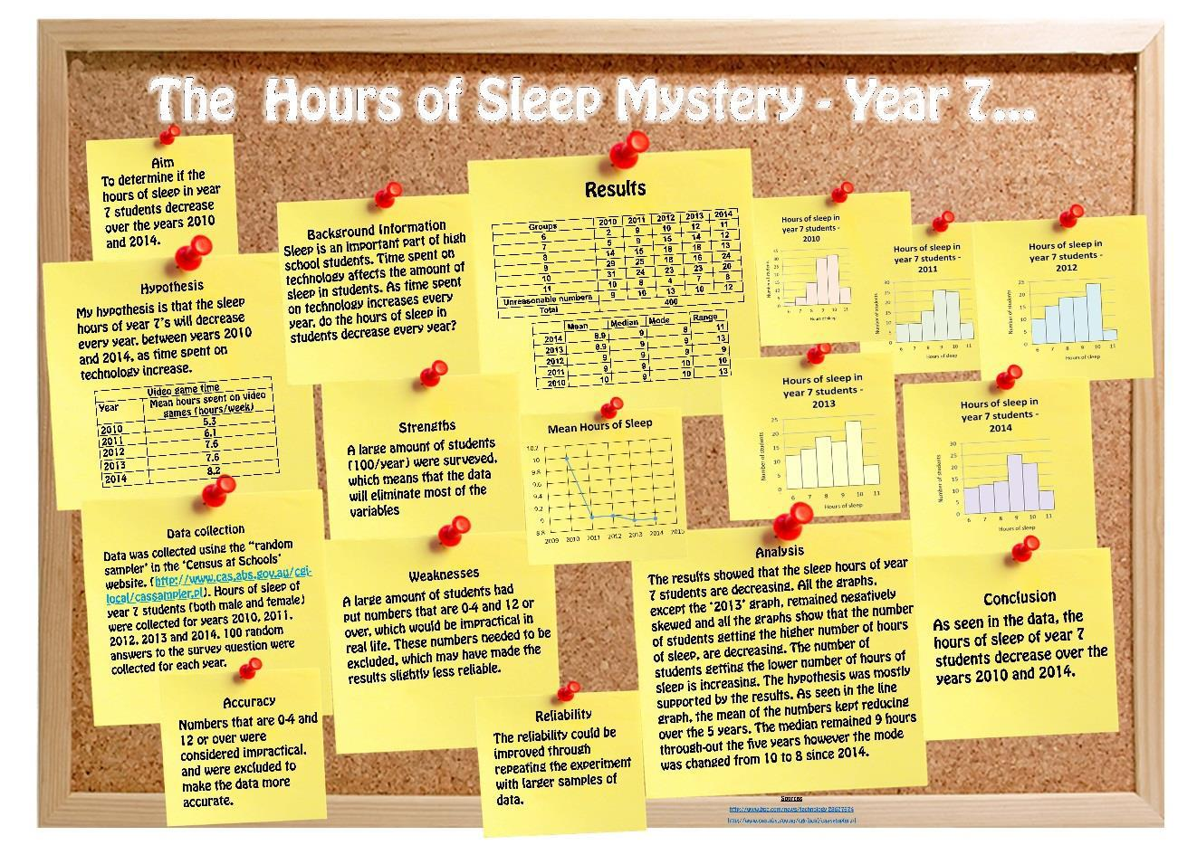
Planning Hints:

A well-considered plan will improve the likely value and success of your project.

Consider the following:

- What types of studies or areas of study may be of interest to you and your team, as well as to others viewing the poster. For example: will it be about sports, or world events, or scientific challenges, or people's attitudes, or animal behaviours, or some other area?

- What is/are the key question/s you wish to address, or hypotheses to test? Can you quantify such hypotheses?

- Can quantitative data be obtained, within your personal constraints and those of the project, that will help you to answer such questions or hypotheses?

- Should, or could, you involve comparisons of groups (e.g., males versus females; between classes; etc.) and in what ways may the groups be compared? This may raise the interest of your project

- If someone else repeated your project would they obtain the same or similar results? Are you attempting to make some generalisations based on a sample?
  - How have you considered variation?
  - How generalised are your results?
- Are you measuring what you intended to measure and need to measure?

- Has everyone involved in collecting data used the same method of measurement and is it the best measure?
  - Why did you measure in a particular way?

- Are you best to report something graphically or via text?
  - does your graph provide a clear message or is it hard to interpret?

- How strong are your conclusions and have you noted limitations and why you were unable to overcome them?

- Is your poster presentation adequately simple and informative?

- Have you used clear headings?

POSTER CHECKLIST

- Clarity of the message:
  - Is the poster understandable without extra information?
  - Are the objectives, research question or hypotheses clear?
  - Are the results and conclusions clear?
  - Is the poster clearly and logically set out?

- Data collection:
  - Are the collected data appropriate for answering the research question?
  - Are the data collection methods clearly stated? (e.g., primary data collection by print, telephone, web survey, or other measurement tools; or secondary sources are cited — published reports, databases etc.)
  - Has quality of the data been considered? (i.e., accuracy of measurements, size of the sample, reliability of sources, methods of sampling, etc.)
  - Has variation been considered when obtaining data?
  - Have comparison groups been considered and well-constructed where applicable?
  - Are the data sources referenced in the poster?
  - Are the survey questions included in the table of results?
  - Has bias in your survey question or sample group been considered?

- Graphs and tables:
  - Are the graphs/tables/statistics appropriate for displaying and summarising the data?
  - Are there adequate graphs/tables from different perspectives?
  - Does every graph/ table add something to the poster?
  - Are the graphs/tables properly titled and explained?

- Calculations
  - Have you included appropriate statistical calculations? (ie mean, mode, median, range, Quartiles, IQR, calculate outliers etc)

- Analysis and conclusions
  - Are the data analysed in terms of the research question or hypotheses?
  - Is the analysis appropriate for the kind of data collected?
  - How well is the research question answered?
  - Are there conclusions and are they supported by the data?
  - Are there any limitations discussed or improvements for future studies suggested?

- Presentation:
  - Is the poster readable from 2 metres (7 feet) away?
  - Is there a good balance between graphs and text?
  - Does the poster look neat?

- Creativity/importance:
  - Is the research question creative, original?
  - Can the study answer an interesting question?
  - Is the design creative and original?
  - Is the poster eye-catching?

- Oral Presentation of your group project:
  - Are you prepared to present the poster to the rest of the class

